PRACTICAL NO 3
AIM:- Working With Apache Pig in MapReduce (cluster) mode
Create a table in the local files
Cmd:-‘Nano file_name.csv’ for text editor ‘ctrl+o’ for saving the file
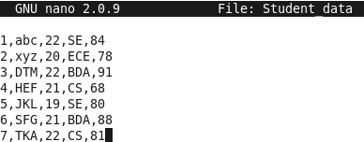
Putting the file from the local machine to the hdfs
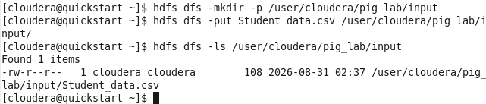
Now to go into the pig just type :-‘PIG’ and enter the grunt shell will be started
To the load the database from hdfs to pig
CMD command
Student= LOAD ‘/user/cloudera/pig_lab/input/Student_data.csv’ USING PigStorage(‘,’) AS (id:int,name:chararray,age:int,dept:chararray,marks:int);
After that just put dump cmd = DUMP students;
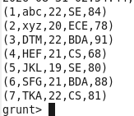

- Extract only the student name and there respective departments
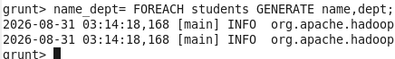
CMD= Dump name_dept;
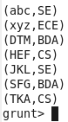

- Filtering data (SQL like WHERE CLAUSE)
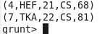

- GROUP DATA
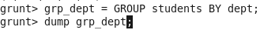
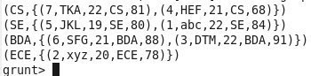

- AGGREGATION FUNCTION
- Calculate the total number of students and average marks per department
CMD:- dept_stat = FOREACH grp_dept GENERATE group AS dept, COUNT(students) AS total_students, AVG(students.marks) as avg_marks;
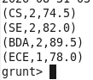
Store the final aggregate function in the hdfs
For viewing the data in the hdfs


